
Western Australian Certificate of Education
Semester One Examination, 2019

Question/Answer Booklet

MATHEMATICS

____
98
SPECIALIST
UNIT 1&2

Section Two:
Calculator- assumed Score for this booklet

Student’s Name: _______________________________________
As shown on your exam timetable.

Student’s Teacher Mr Bradbury Mrs Waddell
(Circle your teacher’s name.)

Time allowed for this section
Reading time before commencing work: ten minutes
Working time for this section: one hundred minutes

Materials required/recommended for this section
To be provided by the supervisor
This question /Answer Booklet
Formula Sheet (retained from Section One)

To be provided by the candidate
Standard Items: pens (blue/black preferred), pencils (including coloured), sharpener,
correction fluid/tape, eraser, ruler, highlighters.
Special items: drawing instruments, templates, notes on two unfolded sheets of A4 paper,
and up to three calculators approved for use in the WACE examinations.

Important note to candidates
No other items may be taken into the examination room. It is your responsibility to ensure
that you do not have any unauthorized notes or other items of a non-personal nature in the
examination room. If you have any unauthorized material with you, hand it to the supervisor
before reading any further.

Section | Number of questions available | Number of questions to be answered |  | Working time (minutes) | Marks available | Percentage of exam
Section One:  Calculator-free | 8 | 8 |  | 50 | 52 | 35
Section Two:  Calculator-assumed | 13 | 13 |  | 100 | 98 | 65
 |  |  | Total |  | 150 | 100

Instructions to candidates

- The rules for the conduct of examinations are detailed in the School Examination Rules provided with your exam timetable. Sitting this examination implies that you agree to abide by these rules.

- Write your answers in this Question/Answer Booklet.

- You must be careful to confine your responses to the specific questions asked and to follow any instructions that are specific to a particular question.

- Spare pages are included at the end of this booklet. They can be used for planning your responses and/or as additional space if required to continue an answer.
- Planning: If you use the spare pages for planning, indicate this clearly at the top of the page.
- Continuing an answer: If you need to use the space to continue an answer, indicate in the original answer space where the answer is continued, i.e. give the page number. Fill in the number of the question(s) that you are continuing to answer at the top of the page.

- Show all your working clearly. Your working should be in sufficient detail to allow your answers to be checked readily and for marks to be awarded for reasoning. Incorrect answers given without supporting reasoning cannot be allocated any marks. For any question or part question worth more than two marks, valid working or justification is required to receive full marks. If you repeat an answer to any question, ensure that you cancel the answer you do not wish to have marked.

- It is recommended that you do not use pencil, except in diagrams.

- The formula sheet and your notes are not to be handed in with your Question/Answer Booklet.

Section Two: Calculator-assumed 65% (98 Marks)
This section has thirteen (13) questions. Answer all questions. Write your answers in the spaces provided.

Working time: 100 minutes.

Question 9 (5 marks)
In the diagram below, $M$ is the midpoint of $QR$.

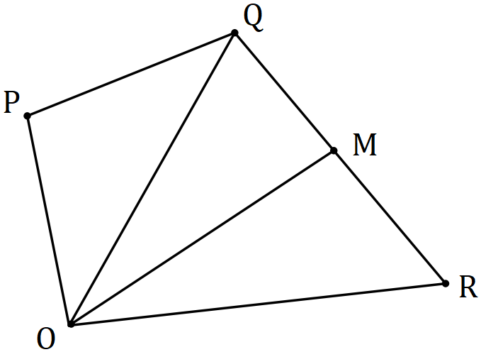

If $\vec{OP}=p, \vec{OQ}=q$ and $\vec{OR}=r$, express the following in terms of $p, q$ and $r$.

(a) $\vec{PR}$. (1 mark)

(b) $\vec{OM}$. (2 marks)

(c) $6\vec{MP}$. (2 marks)

Question 10 (8 marks)
Points $P, Q$ and $R$ have coordinates $\left(-2, 11\right), (8, 15)$ and $(17, 3)$ respectively. Determine

(a) $\vec{PQ}$. (1 mark)

(b) $|\vec{QR}|$. (2 marks)

(c) $2\vec{PQ}-60u$, where $u$ is a unit vector in the direction $\vec{QR}$. (3 marks)

(d) The coordinates of point $S$, given that $\vec{RS}=\vec{QP}$. (2 marks)

Question 11 (7 marks)
(a) In the diagram below (not drawn to scale) $A,B, C$ and $D$ lie on a circle and $EB$ and $ED$ are tangents to the circle. If $∠BED=54°$ and $∠CDB=20°$, determine the size of $∠CBD$.
(3 marks)
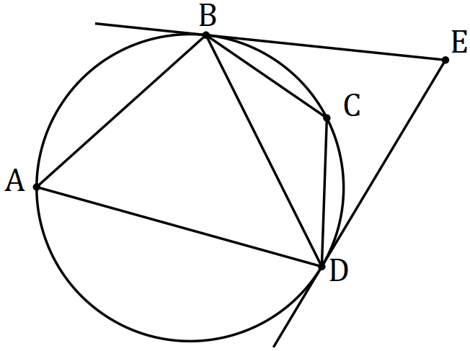

(b) Quadrilateral $ABCD$ is such that $CB=CD$, $∠BAD=96°$ and $∠BDC=48°$.

(i) Sketch a diagram to show this information. (1 mark)

(ii) Show that $ABCD$ is cyclic and hence determine the size of $∠CAD$. (3 marks)

Question 12 (8 marks)
(a) Show that the vectors $\left(8, -5\right)$ and $\left(2.5, 4\right)$ are perpendicular. (2 marks)

(b) Determine, to the nearest degree, the angle between the vectors $\left(3, -2\right)$ and $\left(-2, -4\right)$.
(2 marks)

(c) The vectors $\left(a, 2a+3\right)$ and $\left(a+3, -2\right)$ are perpendicular, where $a$ is a constant. Determine the value(s) of $a$ and the corresponding pair(s) of vectors. (4 marks)

Question 13 (8 marks)
(a) $A, B, C$ and $D$ lie on a circle with diameter $AC$ (diagram not to scale). Determine the size of $∠BDC$ when $∠BCA=25°$. (2 marks)

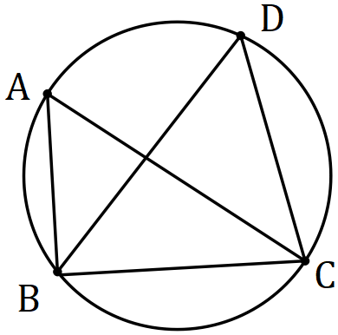

(b) $K, L$ and $M$ lie on a circle (diagram not to scale). Secant $KN$ cuts the circle at $L$ and $JN$ is a tangent to the circle at $M$. Given that $∠LNM=37°$ and $∠LMN=48°$, determine the size of $∠MKL$ and the size of $∠KMJ$. (3 marks)

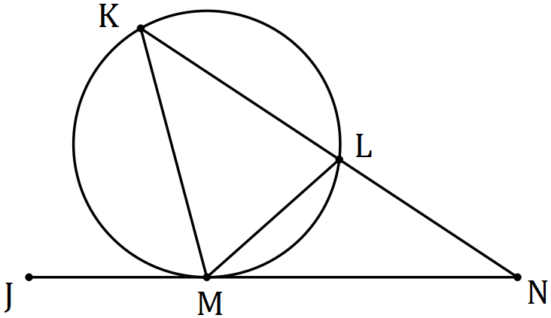

(c) $P, Q$ and $R$ lie on a circle of radius $85$ mm (diagram not to scale) and $PQ=PR=116$ mm. Determine the size of angle $∠QPR$, to the nearest degree. (3 marks)

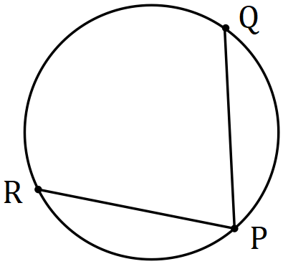

Question 14 (9 marks)
The parts of this question refer to the word AERIFICATION. It has $5$ different consonants and $7$ vowels, some of which are repeated.

(a) Determine the number of ways that $3$ different consonants chosen from the letters of the word can be arranged in a row. (1 mark)

(b) Determine the number of ways that all the letters of the word can be arranged in a row.
(2 marks)

(c) Determine the number of ways that all the letters of the word can be arranged in a row if the vowels must all be adjacent. (3 marks)

(d) Determine how many $3$ letter permutations (e.g. TFI, IRI, etc) can be made using the letters of the word. (3 marks)

Question 15 (8 marks)
(a) In the diagram below (not drawn to scale) $P, Q, R$ and $S$ lie on the circle with centre $O$. Determine the size of angles $α$, $β$ and $γ$ given that $∠PQR=105°$ and $2β=3γ$. (4 marks)

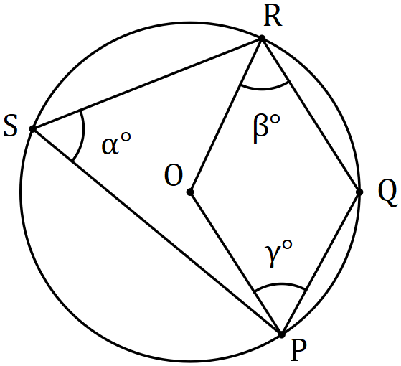

(b) Write the converse of the theorem that states the opposite angles of a cyclic quadrilateral are supplementary. (1 mark)

(c) Prove by contradiction that the converse you wrote in (b) is true. Start by assuming that there is a quadrilateral that does have supplementary opposite angles but is not cyclic, such as $STUW$ shown below. (3 marks)

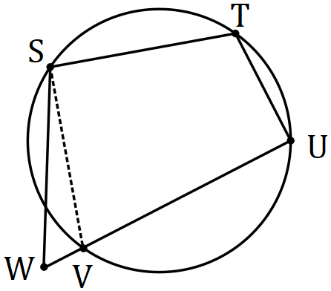

Question 16 (7 marks)
Three forces $a, b$ and $c$ act on a point in a plane.

The forces are$a=-44i+66j N$, $b=-12i-75j$ N and $c=180i+102j N$.

(a) Determine the magnitude of the resultant force and the direction, to the nearest degree, that the resultant makes with the vector $i$. (3 marks)

When $λa+μb+c=0$, the forces are in equilibrium.

(b) Determine the values of the scalar constants $λ$ and $μ$ for equilibrium to occur. (4 marks)

Question 17 (8 marks)
(a) A set of cards is numbered from $100$ to $999$. Determine the minimum number of cards that must be selected to ensure that at least $3$ cards in the selection have the same last digit. Justify your answer using the pigeonhole principle. (3 marks)

(b) Eight different books sit on a shelf, one of which has a hardcover and the rest softcovers. A student is told they can take away as many of them as they like but must not leave empty handed. Determine how many different selections can be made

(i) of exactly $3$ books. (1 mark)

(ii) altogether. (2 marks)

(iii) that include the hardcover. (2 marks)

Question 18 (8 marks)
Relative to the origin, $A$ and $B$ have position vectors $18i+18j$ and $21i-15j$ respectively.

Particle $P$ is initially at $A$ and moves with a constant velocity of $8i-15j$ ms⁻¹.

(a) Calculate

(i) the speed of $P$. (1 mark)

(ii) the position vector of $P$ after $4$ seconds. (1 mark)

(iii) the distance of$P$ from $B$ after $4$ seconds. (2 marks)

(b) Determine how long after leaving $A$ that $P$ is $157$ m from $B$. (4 marks)

Question 19 (7 marks)

$ABCD$ is a trapezium with $\vec{AB}$ parallel and in the same direction to $\vec{DC}$.

(a) Sketch a labelled diagram of $ABCD$. (1 mark)

(b) Show that $\vec{AC}+\vec{DB}=\vec{AB}+\vec{DC}$. (2 marks)

(c) $M$ lies on $AC$ and $N$ lies on $BD$ so that $AM:MC=BN:ND=2:1$. Use a vector method to prove that $ABNM$ is a trapezium. (4 marks)

Question 20 (7 marks)
Farm $A$ lies $95$ km away from farm $B$ on a bearing of $062°$. A helicopter leaves farm $A$ at $7:30$ am to fly to farm $B$. The helicopter can maintain a speed of $145$ kmh⁻¹ and there is a steady wind of $35$ kmh⁻¹ blowing from the north.

Determine the bearing that the helicopter should steer and the time of its arrival at farm $B$, to the nearest minute.

Question 21 (8 marks)
Determine how many of the integers between $1$ and $340$ inclusive are

(a) divisible by $6$. (1 mark)

(b) divisible by $6$ or $7$. (3 marks)

(c) divisible by $6$ or $7$ but not both. (1 mark)

(d) divisible by $6$ or $7$ but not $4$. (3 marks)

Additional working space.

Question Number: _________

